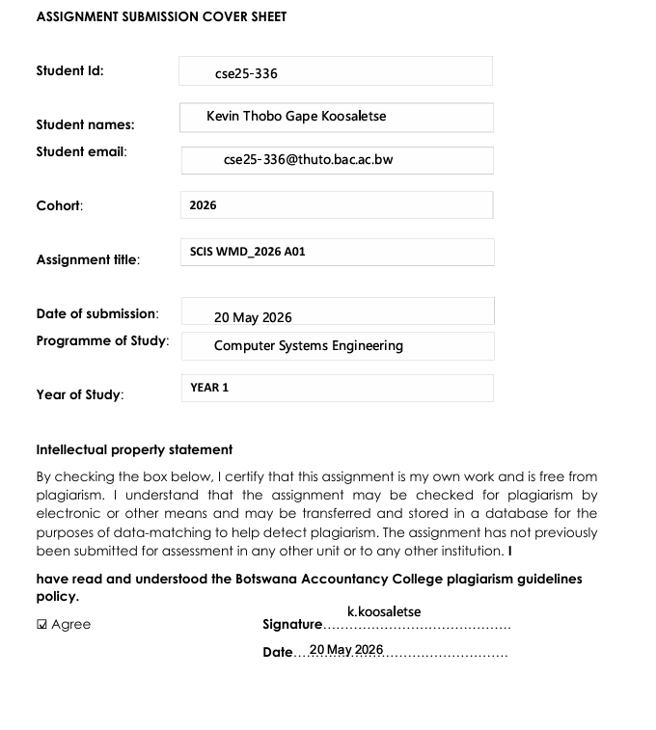
WEBSITE SPECIFICATIONS
OBJECTIVE AND GOALS
- The website is a brochure for Kasane National Park. It was created to inform potential customers about the activities and accommodation of the park.
- The Kasane National Park website was created to persuade more people to visit the site the park by showing amazing wildlife pics and the awesome activities done at Kasane.
- It was also created to answer common questions so that the staff spends less time answering phone calls and emails of their customers.
TARGET AUDIENCE
- The target audience are people who love to travel the world and who are always eager with a passion to explore more about nature.
- According to academic research on Botswana tourism, tourists are motivated to experience “wildlife and wilderness” as a escape from daily routine. (Source: Arizona State University Doctoral Research; Citation: Stone, 2014)
DEMOGRAPHICS
- The demographics of the target audience are people of all genders.
- The age gap of the website users is going to range from 18-45 years.
- Most tourists are in European countries, United States of America and smaller sizes of people come from China. Source:Kutlwano Magazine (Botswana Government) Citation: (Kedidimetse,2024)
TECHNICAL APTITUDE
- According to the age range and location of the website users it is obvious that the target audience has a medium to high level of technical aptitude.
- Since European countries and the USA are one of the most technologically advanced nations in the globe it makes sense to assume that people can use technology with ease. People between the ages of 18-30 grew up with smartphones which resulted in them having a high technical aptitude while people between the ages of 31-45 have used desktops to send emails for work and know the basics of using technology have a medium technical aptitude.
TYPE OF WEBSITE
The type of website being made is a publishing website to advertise what Kasane National Park has to offer and why it should be visited.

INFORMATION DESIGN AND TAXONOMY
Content Categorization
Content was grouped into five main categories based on what a visiting tourist would want to know:
Home (index.html) the entry point. It opens showing a wildlife picture as a background and provides a button that leads to the activities page.
About Us (about.html) provides information on why the park should be visited and the best times to visit the park.
Wildlife (wildlife.html) showcases the park's main attraction. Contains an animal gallery of photographs and a park facts section covering species, conservation status, and ecological information.
Accommodation (accommodation.html) informs visitors about where they can stay. Displays lodge types and an overview of each, along with prices and contact information for direct enquiries. As a publishing website, no online booking is provided.
Activities (activities.html) highlight what visitors can do at the park, including learning the culture, boat cruises and fishing.
Contact Us (contact.html) allows visitors to send enquiries via an HTML5 feedback form.
Site Map
The site map below illustrates the full navigation structure of the website, showing how all pages and sub-sections are interconnected.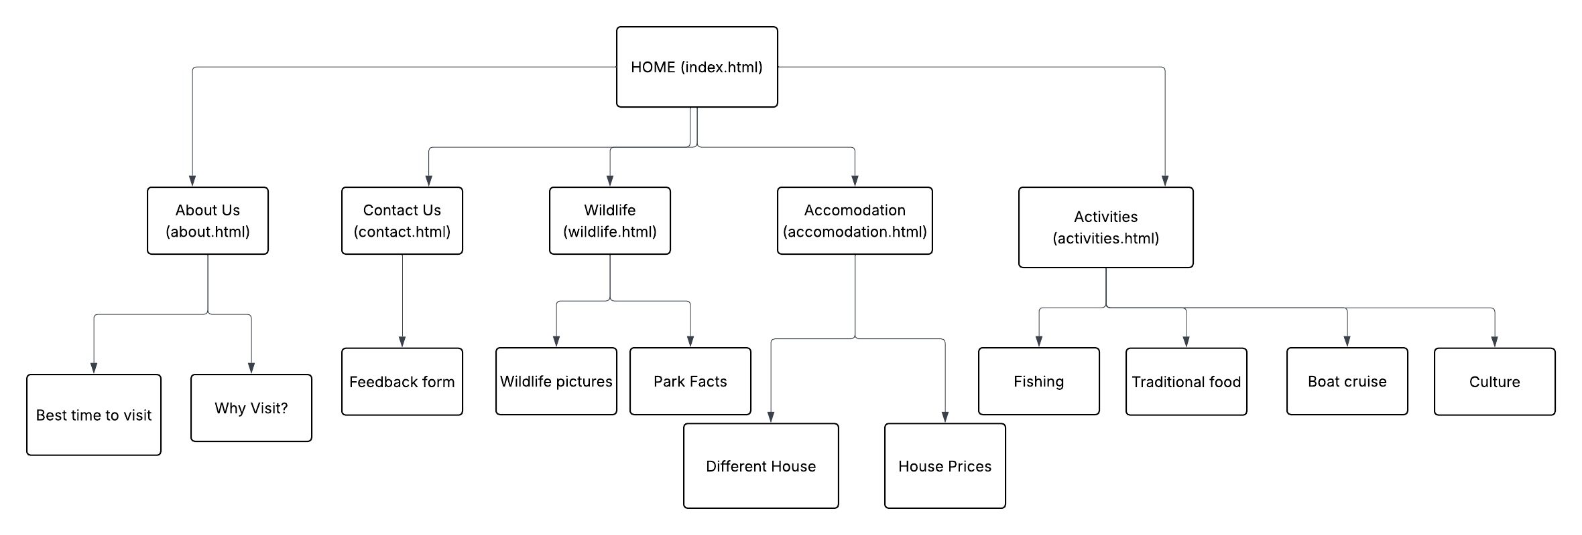
Navigation Design
A persistent global navigation bar will appear at the top of every page, providing one-click access to all five main pages from anywhere on the site.
Three-Click Rule
The 3-click rule states that no piece of content should require more than three clicks to reach from the homepage. This website satisfies it as follows:
- Click 1 — from Home to any main page via the global navigation bar
- Click 2 — from any main page to any sub-section via an in-page anchor link
All content is therefore reachable in a maximum of 2 clicks, which is within the 3-click limit.

TECHNICAL BRIEF
The software tools I am going to use are as listed below.
- GitHub
- Visual Studio Code
- Figma

GitHub
This is where I am going to keep my HTML, CSS and JAVASCRIPT files safely for the website so I can be able to track my code overtime.
GitHub will also be used to host the website on the internet.

Visual Studio Code
This is my programming tool where I am going to be able to create my Html and CSS files

Figma
This is where I am going to create my wireframes and site map for my website so I can plan decisively my website.

GOOGLE AND MICROSOFT EDGE BROWSERS
These browsers are going to be used for testing the websites to see if it works properly.

